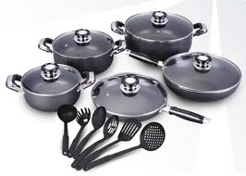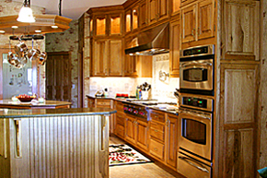[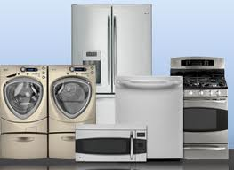](http://www.google.com/imgres?hl=en&gbv=2&biw=1366&bih=650&tbm=isch&tbnid=NIl5uKAilMB40M:&imgrefurl=http://www.geconsumerandindustrial.com/hr/careers/appliances.htm&docid=rplBnP2bYLhzJM&imgurl=http://www.geconsumerandindustrial.com/hr/careers/images/main_image_appliances.jpg&w=331&h=242&ei=d8eUT9rBMcWg6QGnzcS8BA&zoom=1&iact=hc&vpx=1060&vpy=204&dur=3915&hovh=192&hovw=263&tx=210&ty=43&sig=112693540307853220848&page=2&tbnh=147&tbnw=198&start=12&ndsp=24&ved=1t:429,r:5,s:12,i:180)

**AT RALPH’S JOY OF LIVING,**

**ralphsjol.com**

**WINE**

**CABINETRY**

**COOKWARE**

**APPLIANCES**

**EXPERIENCE THE JOY OF…**

**ralphsjol.com**

**33 N. Washington Street, Tiffin, OH**

**OF COOKWARE**

**RALPH’S JOY OF LIVING**

**EXPERIENCE THE JOY**

**RALPH’S JOY OF LIVING**

**ralphsjol.com**

**33 N. Washington Street, Tiffin, OH**

**OF CABINETRY**

**EXPERIENCE THE JOY**

**OF APPLIANCES**

**EXPERIENCE THE JOY**

**RALPH’S JOY OF LIVING**

**ralphsjol.com**

**33 N. Washington Street, Tiffin, OH**

**TH**

**65**

**ANNIVERSARY**

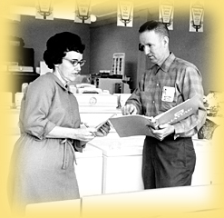

**1950-2015**

**BARBECUE**

**FACE PAINTING**

**HANDS-ON**

**BOUNCE HOUSE**

**COME EXPERIENCE THE JOY OF 65 YEARS IN THE MAKING!**

**RALPH’S JOY OF LIVING**



**ralphsjol.com**

**33 N. Washington Street, Tiffin, OH**

**RALPH’S JOY OF LIVING**

**65TH ANNIVERSARY**

**BARBEQUE BASH!!!**

**COME EXPERIENCE**

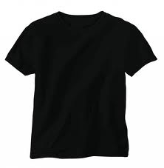

**THE JOY OF 65 YEARS IN THE MAKING**

[Type a quote from the document or the summary of an interesting point. You can position the text box anywhere in the document. Use the Drawing Tools tab to change the formatting of the pull quote text box.]

**TH**

**RALPH’S JOY OF LIVING**

**65**

**ANNIVERSARY**



**1950-2015**

EXPERIENCE THE JOY

[](http://www.google.com/imgres?hl=en&gbv=2&biw=1366&bih=650&tbm=isch&tbnid=7KcTHyyPHI7OuM:&imgrefurl=http://fooyoh.com/fitness_health/5255166&docid=wSlQzlPT5Mgn_M&imgurl=http://maxcdn.fooyoh.com/files/attach/images/613/166/255/005/group_drinking_wine_7oxt.jpg&w=630&h=559&ei=SMGUT4v_Kc_k6QHztrWvBA&zoom=1&iact=hc&vpx=874&vpy=204&dur=449&hovh=211&hovw=238&tx=132&ty=49&sig=112693540307853220848&page=3&tbnh=146&tbnw=165&start=46&ndsp=25&ved=1t:429,r:23,s:46,i:248)

**OF WINE**

**RALPH’S JOY OF LIVING**

**ralphsjol.com**

**33 N. Washington Street, Tiffin, OH**

**RALPH’S JOY OF LIVING**

**65**

**ANNIVERSARY**



**1950-2015**

**TH**

C:\Users\owner\AppData\Local\Microsoft\Windows\Temporary Internet Files\Content.IE5\3U7S3WMO\MC900280971[1].wmfC:\Users\owner\AppData\Local\Microsoft\Windows\Temporary Internet Files\Content.IE5\LM9D97QX\MC900013359[1].wmfC:\Users\owner\AppData\Local\Microsoft\Windows\Temporary Internet Files\Content.IE5\RZNE4YVH\MC900021394[1].wmfC:\Users\owner\AppData\Local\Microsoft\Windows\Temporary Internet Files\Content.IE5\E7O1ZY29\MC900232116[1].wmf

**ralphsjol.com**

**33 N. Washington Street, Tiffin, OH**

**RALPH’S JOY OF LIVING**